**NATIONAL INSTITUTE OF TECHNOLOGY SILCHAR**

**Cachar, Assam**

**B.Tech. IVth Sem**

**Subject Code:** CS216

**Subject Name:** Applied Probability

**Submitted By:**

Name : Subhojit Ghimire

Sch. Id. : 1912160

Branch : CSE – B

1. Write a simple program to export and import data, using R. Take a screenshot of your desktop showing the above and submit the screenshot

* R code to export data:

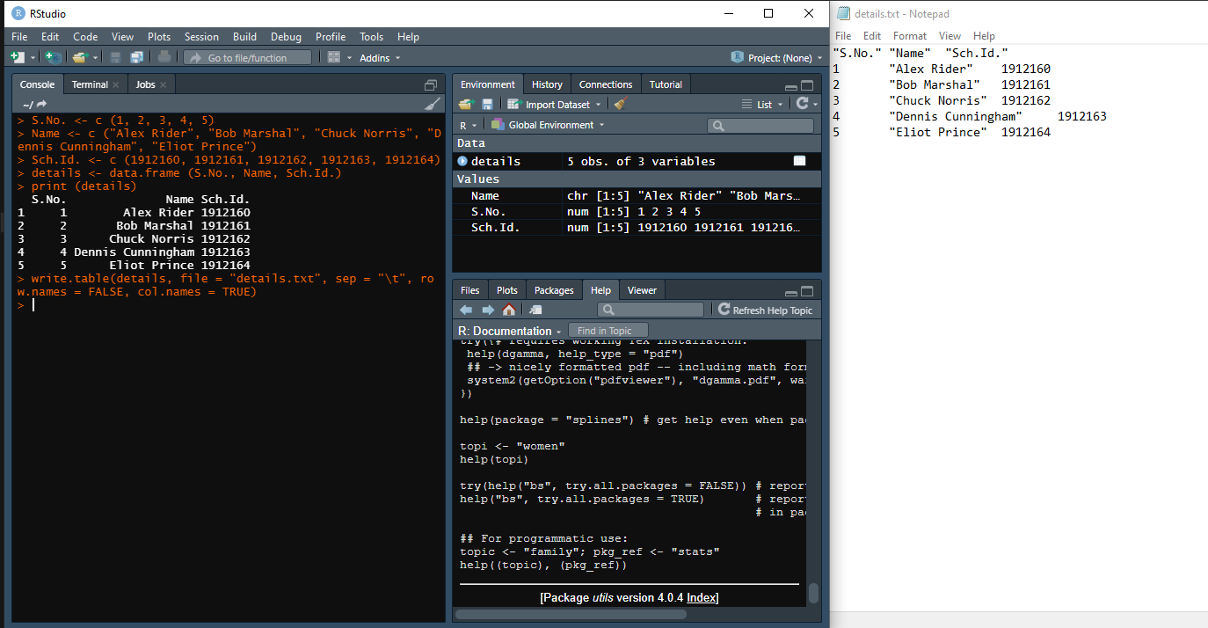

* R code to import data:

